**Lab 9C**

**Lab 9C - Code**

**IC_Bug.py**

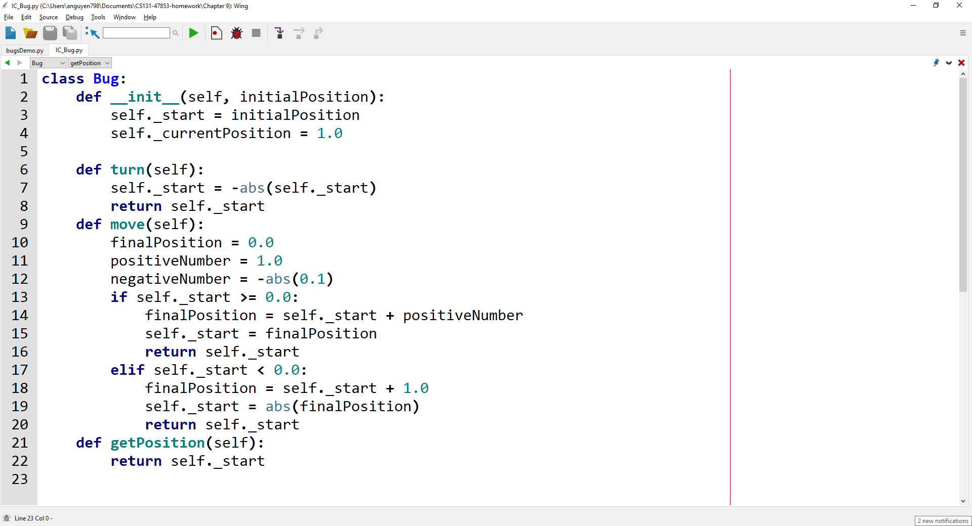

**bugsDemo.py**

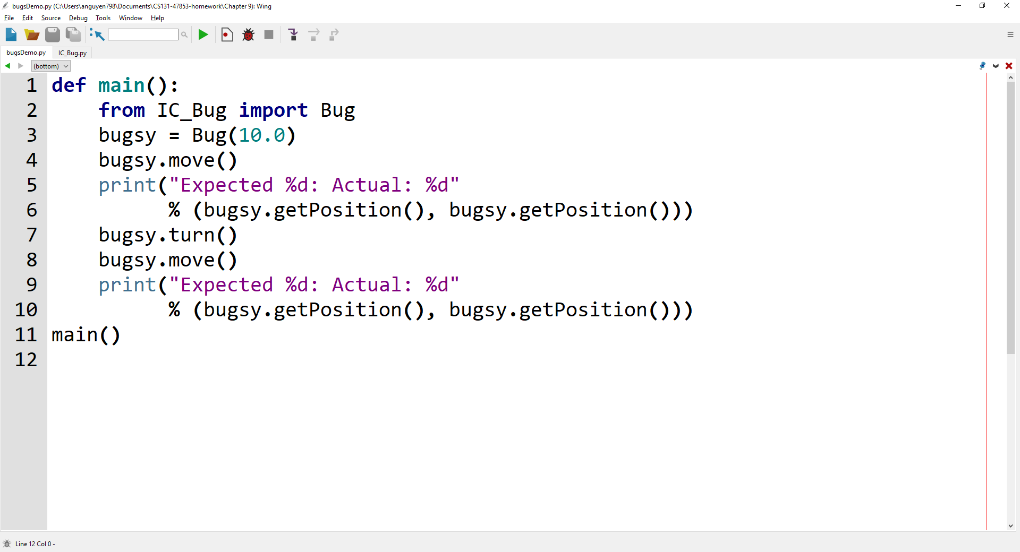

**Lab 9C - Output**

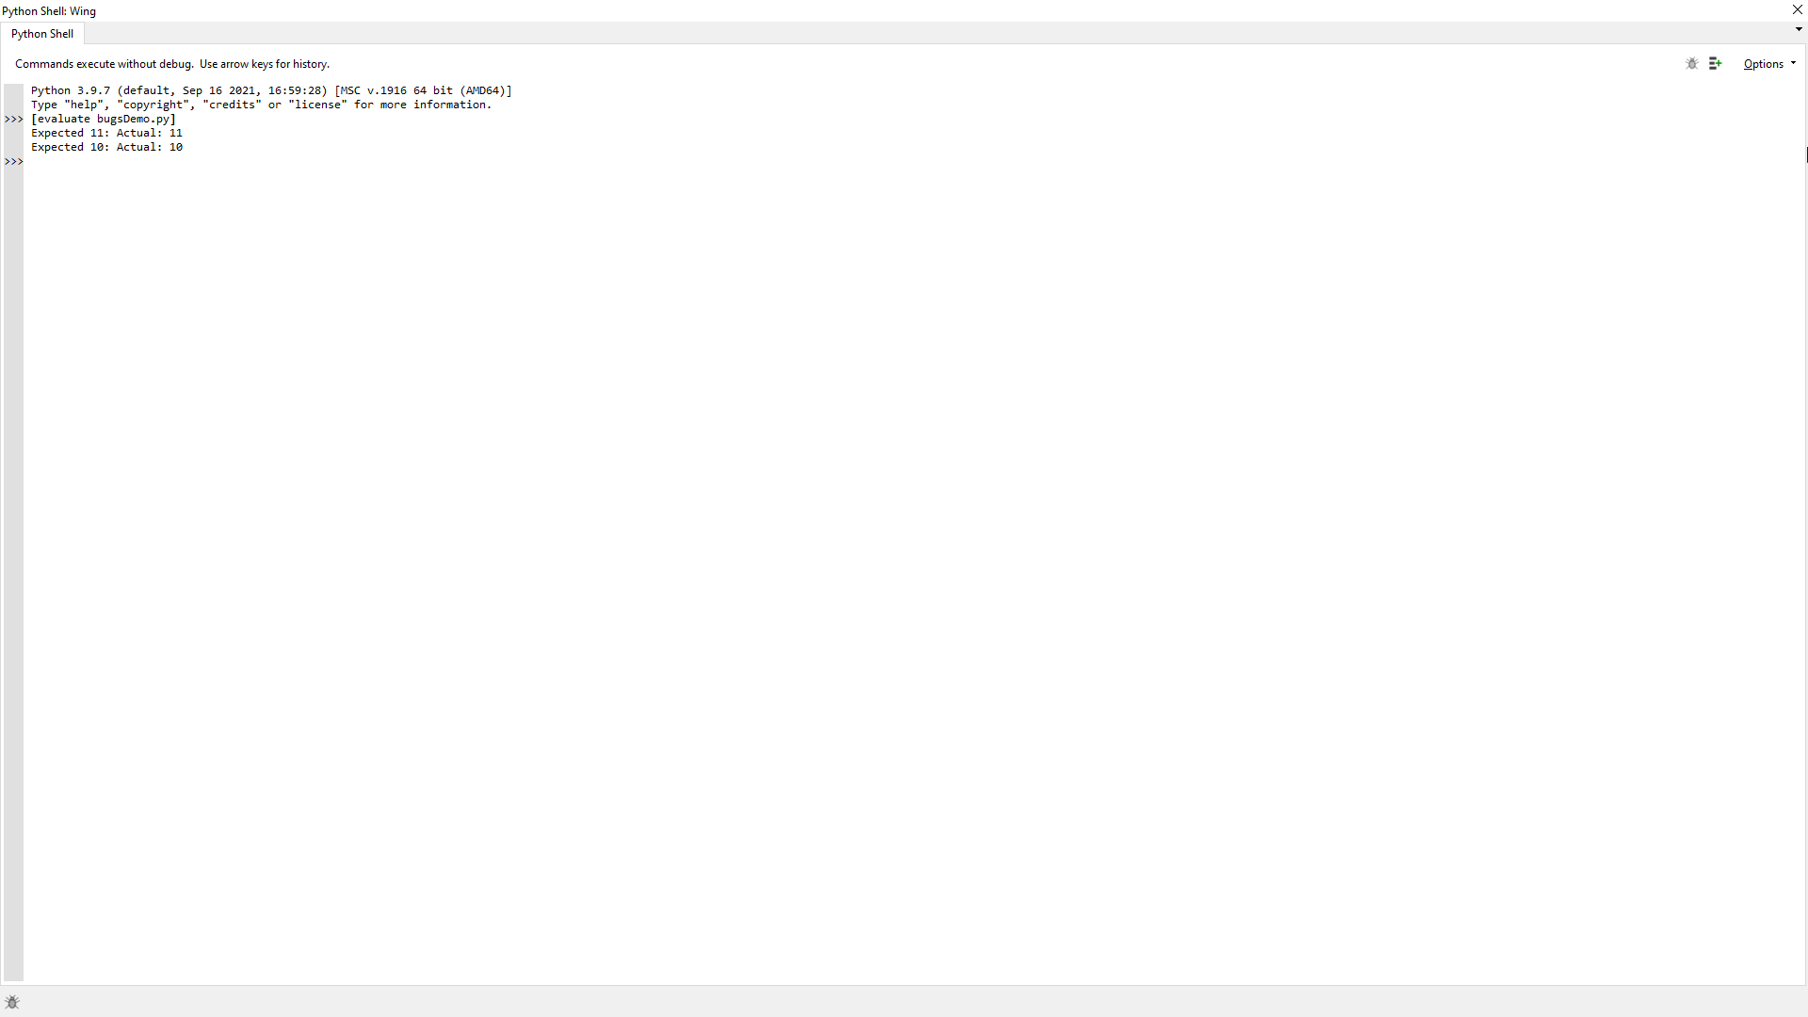

**Lab 9C – Written Code**

**IC_Bug.py**

class Bug:

    def __init__(self, initialPosition):

        self._start = initialPosition

        self._currentPosition = 1.0

    def turn(self):

        self._start = -abs(self._start)

        return self._start

    def move(self):

        finalPosition = 0.0

        positiveNumber = 1.0

        negativeNumber = -abs(0.1)

        if self._start >= 0.0:

            finalPosition = self._start + positiveNumber

            self._start = finalPosition

            return self._start

        elif self._start < 0.0:

            finalPosition = self._start + 1.0

            self._start = abs(finalPosition)

            return self._start

    def getPosition(self):

        return self._start

**bugsDemo.py**

def main():

    from IC_Bug import Bug

    bugsy = Bug(10.0)

    bugsy.move()

    print("Expected %d: Actual: %d"

          % (bugsy.getPosition(), bugsy.getPosition()))

    bugsy.turn()

    bugsy.move()

    print("Expected %d: Actual: %d"

          % (bugsy.getPosition(), bugsy.getPosition()))

main()